About the Dataset

Type: Retail / E-commerce Dataset
Customer Behaviour
Analysis
Nature: Structured (Tabular)
Level: Customer Transaction Level
Data Mix:
Numerical → Age, Purchase Amount, Previous Purchases Categorical → Category, Payment Method, Season
This dataset is used for customer behavior analysis + business decision-making

Domain Background
In the e-commerce industry, companies track every customer interaction: What customers buy
How often do they buy
How much do they spend
Whether they respond to discounts
Why This Data Is Important
This data helps businesses:
Identify high-value customers Understand purchase patterns Optimize discount strategies
Improve marketing campaigns
Increase customer lifetime value (CLV)

Business Problem
How can a retail company understand customer purchasing behavior to increase revenue, improve customer retention, and optimize marketing strategies?
Breaking Down the Problem
Low Customer Retention

Customers are not purchasing frequently

Need to understand:

Who are frequent buyers? Who are one-time buyers?
Ineffective Marketing Campaigns

Discounts and promo codes may not be effective

Questions:

Do discounts increase purchases?
Which customers respond to promo codes?

Product Demand Understanding

Which category performs best?
Which products generate the highest revenue?

Payment Behavior Insights

Which payment methods are preferred? Are digital payments increasing?
Seasonal Demand Variation

Does season impact sales?
Which season drives maximum purchases?

Customer Segmentation Problem

Need to identify:

High-value customers Frequent buyers
Discount-sensitive customers

Data Dictionary

Column Name | Description
Customer ID | Unique identifier for each customer
Age | Age of the customer
Gender | Gender of the customer (Male/Female/Other)
Item Purchased | Specific product purchased
Category | Product category (Clothing, Electronics, etc.)
Purchase Amount | Amount spent by the customer
Location | Customer’s geographic location
Size | Product size (S, M, L, etc.)
Color | Product color
Season | Season of purchase (Winter, Summer, etc.)
Review Rating | Customer rating for the product
Subscription Status | Whether customer is subscribed (Yes/No), Subscription Program
Shipping Type | Type of shipping selected
Discount Applied | Whether discount was applied
Previous Purchases | Number of past purchases
Payment Method | Mode of payment
Frequency of Purchases | Purchase frequency (Weekly, Monthly, etc.)

EDA- ( Exploratory Data Analysis using Python)

Data Loading
What you did:

Imported pandas
Loaded dataset using:
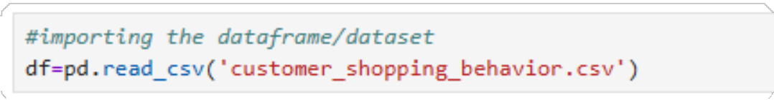
Why did you do it:

To bring raw data into a structured DataFrame Enables further analysis and transformations
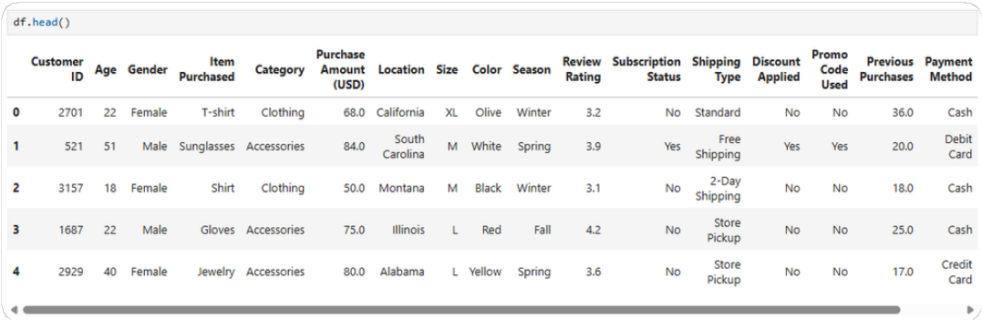

Initial Data Exploration
Process:

Viewed data using: df.head()
df.tail()
Checked dataset summary:
df.describe(include='all') df.info()
Checked missing values: df.isnull().sum()

Why?
To understand:
Data structure Data types
Missing values
This step helps identify data quality issues early

Data Consistency Check (Category Correction)
What you did:

Checked unique values in: Item Purchased
Category
Found inconsistencies between Item Purchased and Category
Created a mapping dictionary
Updated category using:

Why did you do it?

Categories were inconsistent or incorrect Ensures:
Accurate grouping
Correct business insights

This is a critical real-world data cleaning step

Handling Missing Values (Size Column)
What you did:

Handled missing values based on category:

Electronics → "Not Applicable." Accessories → "Not Applicable." Footwear → "Free Size."
Clothing → Filled with mode

Why did you do it?

Different categories require different business logic
Example:
Electronics don’t have size → Not Applicable Clothing → size is important → use mode
This shows domain understanding

Handling Missing Values (Review Rating)
What you did:

Checked:
Mean, median, mode
Filled missing values using: Rounded values
Why did you do it:

Instead of the global average, the product-level mean is used
This keeps ratings realistic and meaningful

This is an advanced imputation technique

Handling Missing Values (Purchase Amount)
What you did: Replaced with the mean value. Why did you do it?
Maintains product-level pricing consistency
Avoids distortion in revenue analysis

Handling Missing Values (Previous Purchases)
What you did: Replaced with the 0 (zero) value. Why did you do it:
Missing values imply no previous purchase
Important for:
Customer segmentation Loyalty analysis

Duplicate Handling
What you did:

Checked duplicates:
Identified duplicates using Customer ID Removed duplicates:
Why did you do it?

Ensures:
Each customer appears only once No double-counting in analysis
Critical for accurate reporting

Column Standardization
What you did:

Converted column names:

df.columns = df.columns.str.replace(" ","_") df.columns = df.columns.str.lower()
Renamed column:
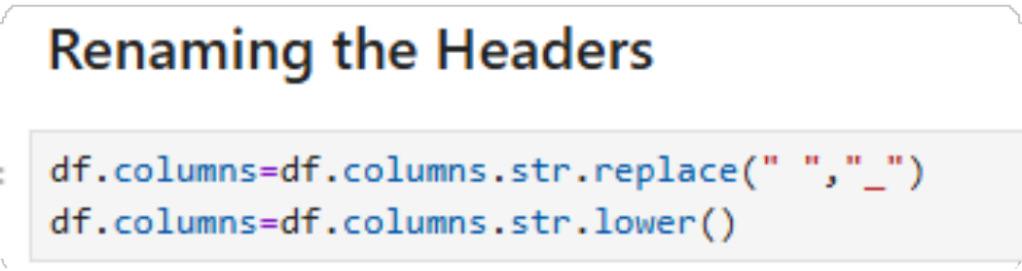
Why did you do it?

Makes column names: Clean
SQL-friendly
Easy to use in Power BI

Data Export to SQL Server
What you did:

Installed required libraries:

pip install pyodbc sqlalchemy

Connected to SQL Server Exported data:
Why did you do it?

To move cleaned data into SQL for further analysis

Enables:
Query-based insights
Integration with BI tools.
Data Analysis using SQL Server

- Which category generates the highest revenue?
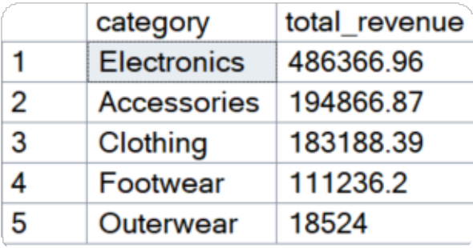
- Are discounts actually increasing purchase value?
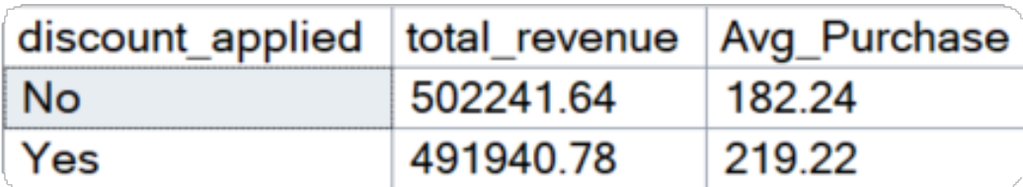
- What is the total revenue generated by male and female customers?
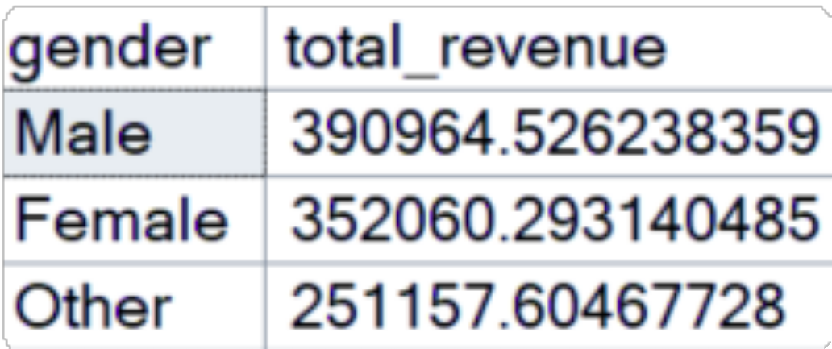

- Which customer used a discount but still spent more than the average purchase amount?
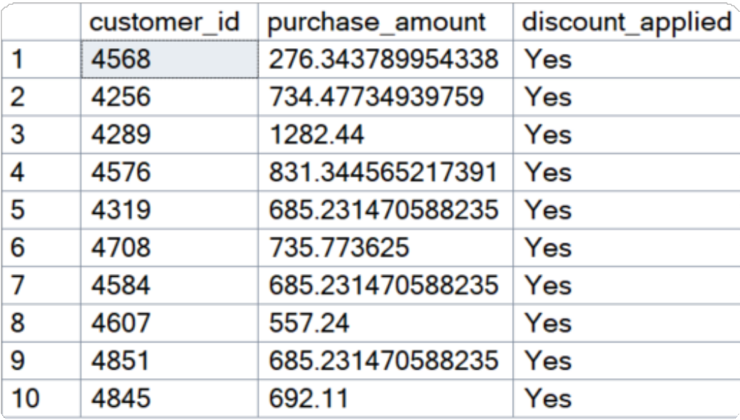
- Which are the top/bottom 5 products with the highest average review rating?

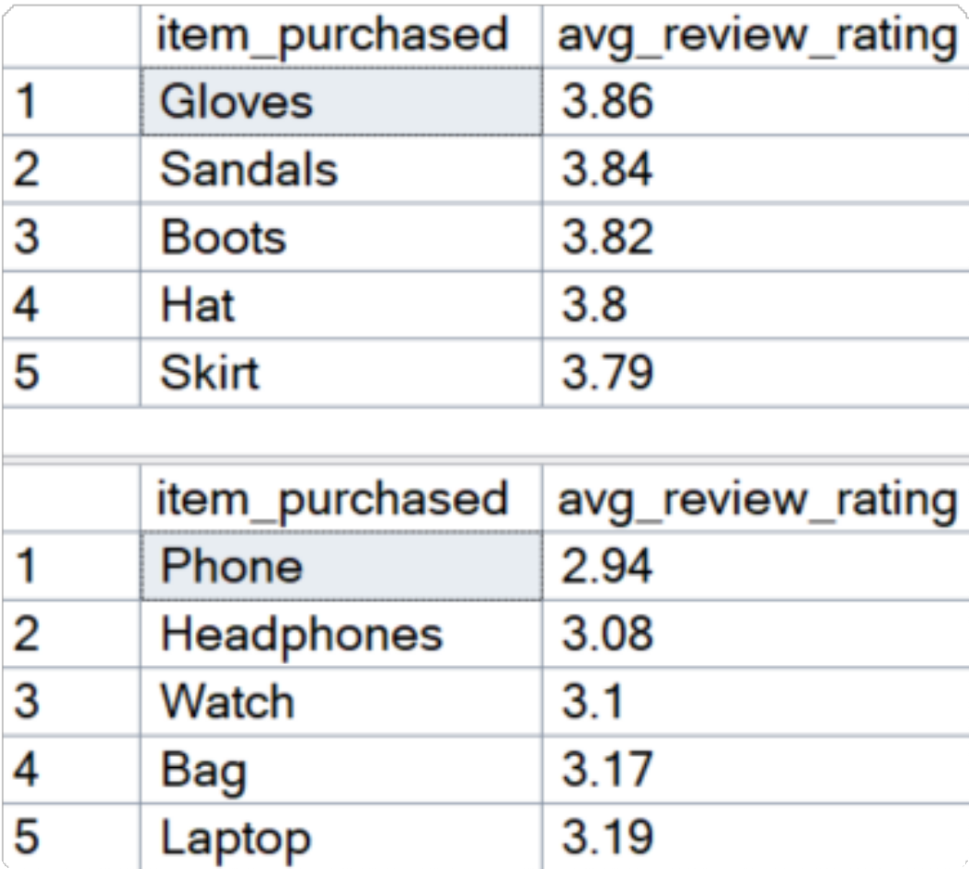
- Average purchase: Standard vs Express shipping
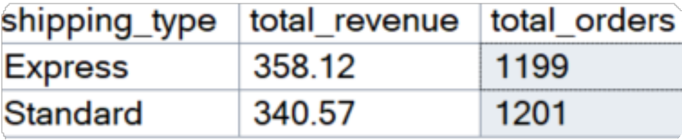
- Do subscribed customers spend more? Compare average speed and total revenue between subscribers and non-subscribers.
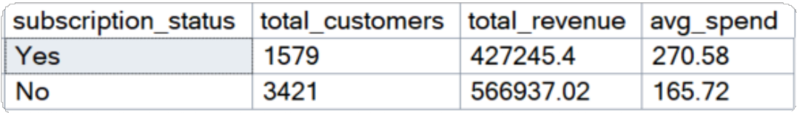

- Top 5 products with highest discount usage %
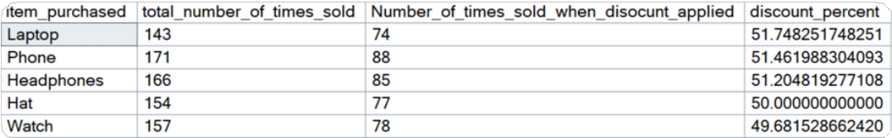
- Segment customers into new, returning, and loyal based on their total number of previous purchases, and show the count of each segment.

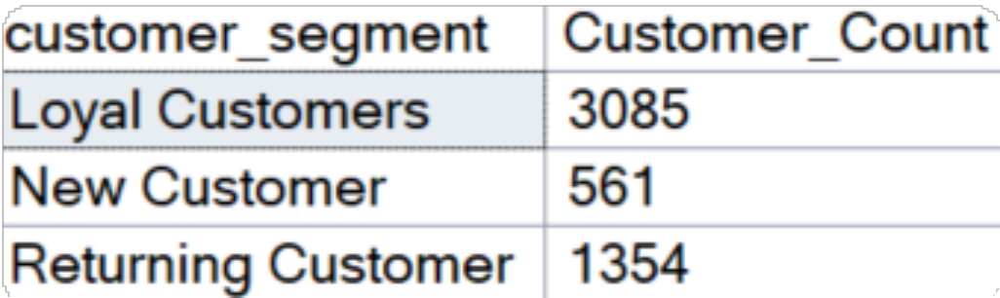

- What are the top 3 most purchased products within each category?
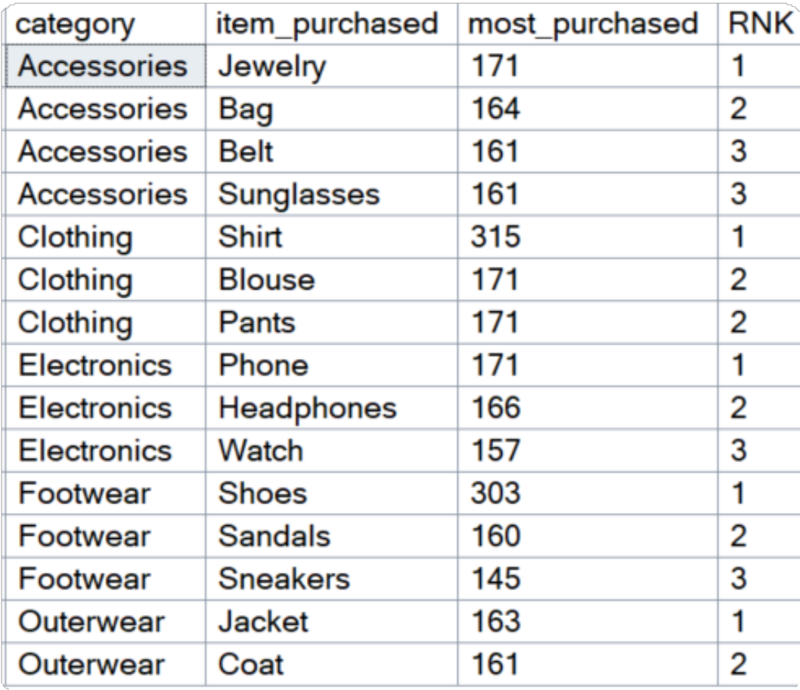

- Are customers who are repeat buyers (more than 5 previous purchases) also likely to subscribe?

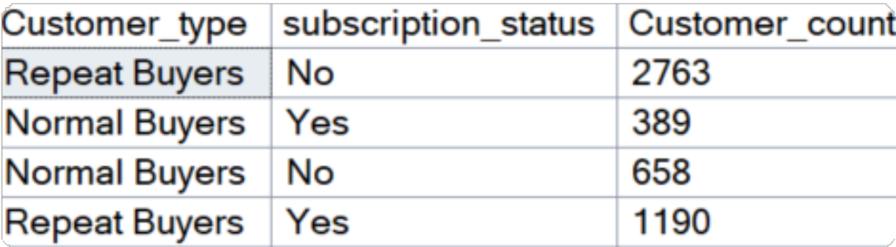

- What is the revenue contribution of each age group?

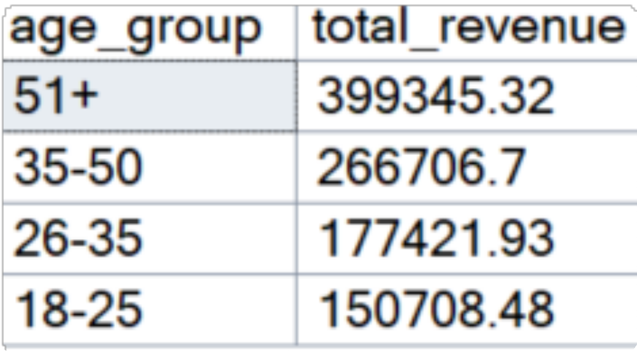

Power BI Dashboard

